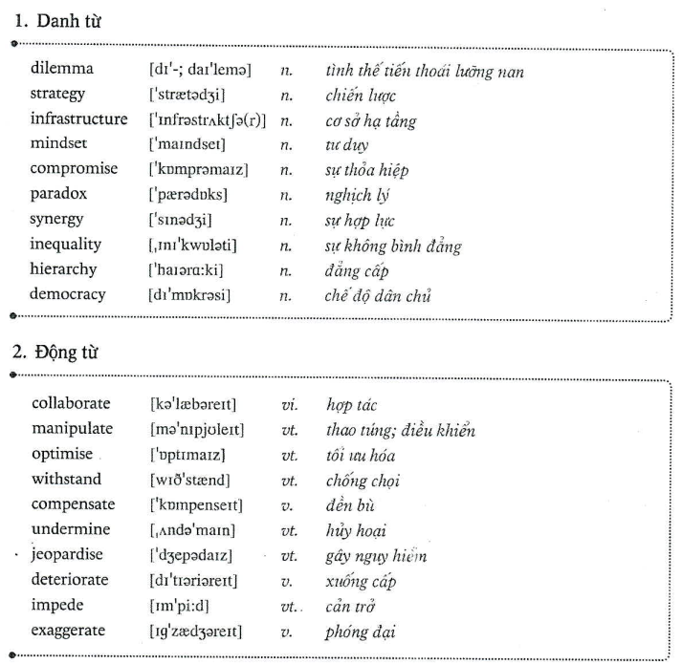

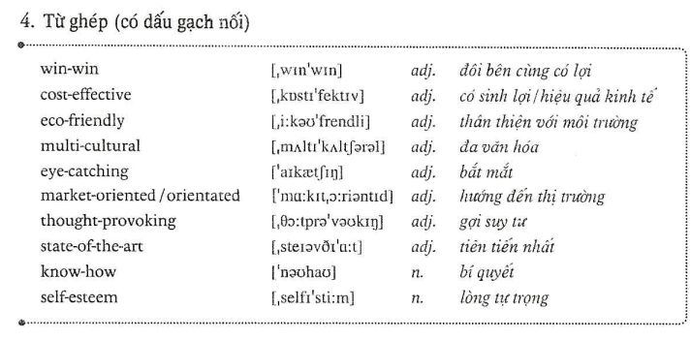

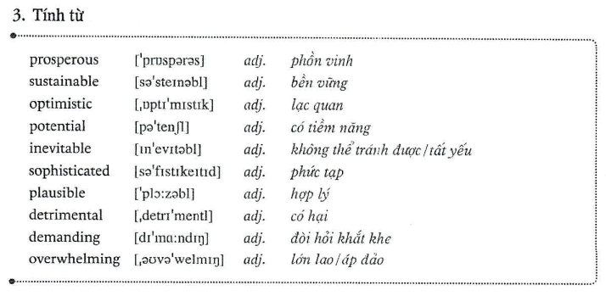

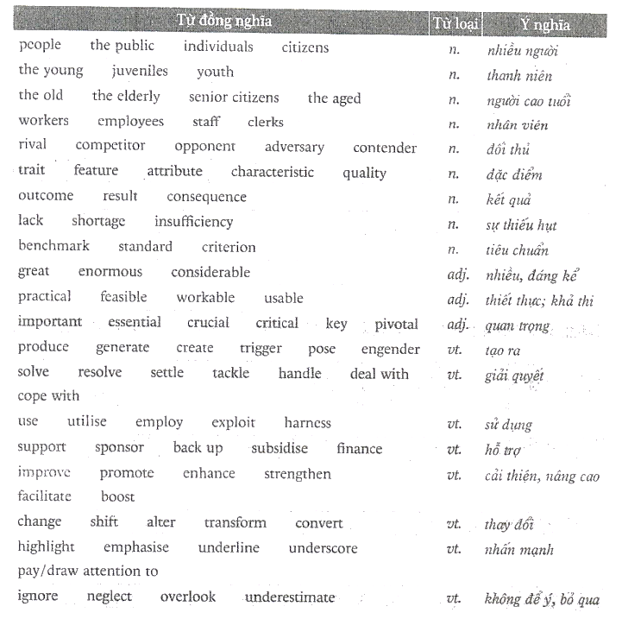

Junior citizens
youngsters

Young people should help old people.
In my opinion, youngsters should help support/ assist the elderly with some heavy work.

Good result ~ …bright/ great outcome => considerable outcome

I cannot buy this car because I don’t have money.
Can ~ to be able to
I am unable to purchase this automobile due to my insufficiency of financial resource.
He can swim => he is able to swim after two weeks of training.
Great improvement~ He has/ shows a considerable improvement because he is able to swim after two weeks days of training.
This is a good feasible solution.
This is a good feasible solution because it creates generates a lot of jobs career opportunities for young people the young/ youngsters.

B1
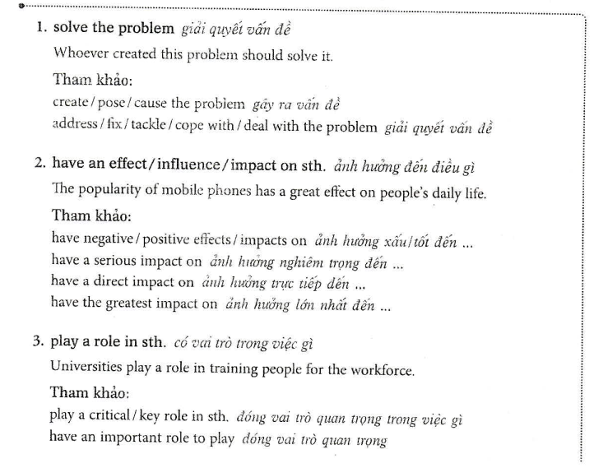
tackle the (current~hien nay) issue
issue

Play an essential role in

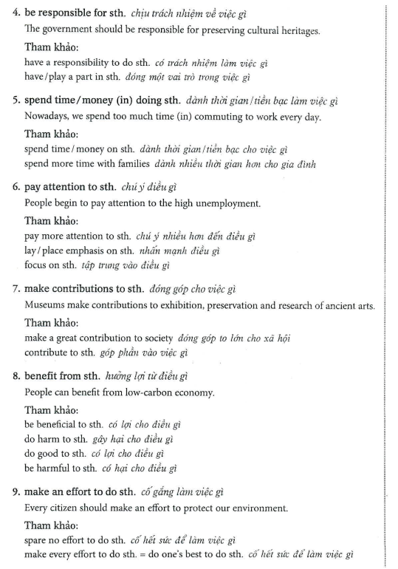

Pa

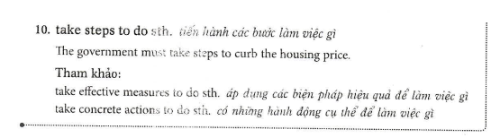

B2
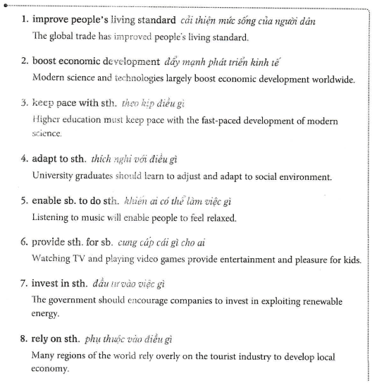

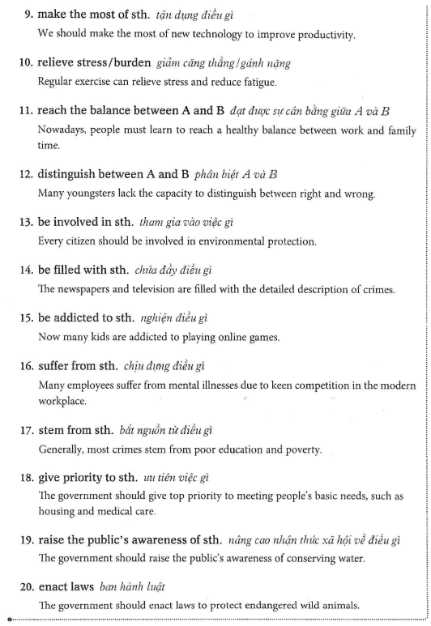

Vì thế =>... ; therefore, ...
C1
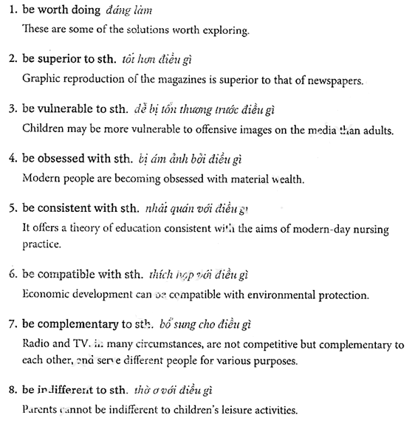

At the end of the day,... => finally
All things considered, I would recommend
When it comes to ...,~about
What I found particularly fascinating about this story is...
Not only is the plot great, but it is also very well written.

I really like going to the cinema with my friends.=>B1
What I really like is going to the cinema with my friends.

What-clauses...
Only by+ ving, inversion
I think you should go to the doctor =>B1
Only by going to the doctor, your health could be improved.
Only by going to the doctor, could your health cbe improved.
The plot is not only great but also very well written.
=> Not only is the plot great, but it is also very well written.

